American College of Surgeons Motor Vehicle Legislative Toolkit
This document is an assortment of talking points, data, and facts about the benefits of improving motor vehicle safety through reducing the rates of distracted driving and improving the use of seatbelts. Overall, this toolkit can be used to help inform Fellows of The American College of Surgeons (ACS) about advocacy regarding the public health benefits of enhanced motor vehicle safety legislation and educate lawmakers on the public health benefits of enhanced distracted driving laws.
Included in this toolkit are the following:
- Background on distracted driving and the use of seatbelts
- Current status of distracted driving laws in the states
- Current status of seatbelt laws in the states
- Sample letter to legislators
- Sample action alerts
- Model bills
- Resources

Background on Motor Vehicle Safety Issues and Solutions
Motor vehicle crashes are a leading cause of death among those aged 1-54, and most of these deaths happen to drivers and passengers.¹ According to the National Highway Traffic Safety Administration (NHTSA), traffic fatalities have increased by more than 10% in the first half of 2016, after increasing by over 7% in 2015.² The NHTSA is focusing on a number of ways to reduce these fatalities, including on increasing seatbelt use and reducing distracted driving.³
Distracted Driving
Distracted driving is an emerging and growing threat to vehicle occupants, pedestrians and bicyclists. Distracted driving is defined as any activity that takes a driver’s attention from focusing on the road. This includes texting and cell-phone use, but also eating, talking to other passengers, adjusting the radio, and so on.
In 2014, 10 percent of fatal crashes, 18 percent of injury crashes and 16 percent of police-reported motor vehicle crashes were reported as distraction-affected crashes.⁴ An estimated 3,179 people were killed, 431,000 people were injured, and 520 non-occupants (pedestrians, bicyclists) were killed in motor vehicle crashes involving distracted driving.⁴
Although younger drivers might feel more comfortable and confident with using cell phones and other technologies, they account for more fatal distracted-driving crashes, including those involving cell phones, than any other age group.⁴
Distracted driving is a very dangerous behavior that increases the risk of a crash and crash-related injuries or death.
Seatbelt Use
Using a seatbelt is the most effective way to both save lives and reduce the severity of injuries in motor vehicle crashes. Seatbelts reduce serious injuries caused by car crashes by an estimated 50 percent.⁵ In 2015, it is estimate they saved 13,941 lives of vehicle occupants over the age of 5 in 2015 (child restraints for those under 5 saved an additional 266 lives).⁶ More than 2,800 lives could have been saved if every vehicle occupant wore a seatbelt.⁶
The national rate of seatbelt use in 2015 was 88.5 percent.⁶ Seatbelt use varies wildly between states, from a low in New Hampshire of 69.5 percent to a high of 97.3 percent in Georgia and California.⁶ States with stronger seatbelt enforcement laws exhibit a higher rate of use than states with weaker enforcement laws.⁶ For example, in states with primary enforcement laws seat belt use in 2015 was 91% but only 79% in states with secondary enforcement laws or no seat belt laws.⁷
Increasing the use of seatbelts to 100 percent will reduce the severity of injuries and save lives.

- National Highway Traffic Safety Administration. Traffic Safety Facts: 2014 Data – Occupant Protection. Washington, DC: US Department of Transportation, National Highway Traffic Safety Administration; 2016. Publication no. DOT-HS-812-262. Available at https://crashstats.nhtsa.dot.gov/Api/Public/ViewPublication/812262
- National Center for Statistics and Analysis. (2016, September). Early estimate of motor vehicle traffic fatalities for the first half (Jan–Jun) of 2016 (Crash Stats Brief Statistical Summary. Report No. DOT HS 812 332). Washington, DC: National Highway Traffic Safety Administration. Available at: https://crashstats.nhtsa.dot.gov/Api/Public/ViewPublication/812332.
- U.S. DOT, National Safety Council launch 'Road to Zero' Coalition to end roadway fatalities. Press Release, October 5, 2016. Washington, DC: National Highway Traffic Safety Administration. Available at: http://www.nhtsa.gov/About+NHTSA/Press+Releases/nhtsa-zero-deaths-coalition-10052016.
- National Center for Statistics and Analysis. (2016, April). Distracted driving 2014 (Traffic Safety Facts Research Note. Report No. DOT HS 812 260). Washington, DC: National Highway Traffic Safety Administration. Available at: https://crashstats.nhtsa.dot.gov/Api/Public/ViewPublication/812260.
- Kahane CJ. Fatality reduction by safety belts for front-seat occupants of cars and light trucks: updated and expanded estimates based on 1986-99 FARS data. Washington, DC: US Department of Transportation, National Highway Traffic Safety Administration; 2000. Publication no. DOT-HS-809-199. Available at http://www-nrd.nhtsa.dot.gov/Pubs/809199.PDF.
- Chen, Y. Y., & Webb, C. (2016, May; Rev. 2016, June). Seat belt use in 2015—Use rates in the States and Territories (Traffic Safety Facts Crash Stats. Report No. DOT HS 812 274). Washington, DC: National Highway Traffic Safety Administration. Available at: https://crashstats.nhtsa.dot.gov/Api/Public/ViewPublication/812274.
- National Highway Traffic Safety Administration. Traffic Safety Facts: Seat Belt Use in 2015 – Overall Results. Washington, DC: US Department of Transportation, National Highway Traffic Safety Administration; 2016. Publication no. DOT-HS-812-243. Available at http://www-nrd.nhtsa.dot.gov/Pubs/812243.pdf.
Cell Phone Use and Distracted Driving
While many different activities can distract a driver, text messaging requires visual, manual, and cognitive attention from the driver so it has become the most worrying distraction. According to the National Highway Traffic Safety Administration, there were 385 fatal crashes (with a total of 404 fatalities) reported to have been caused by the distraction of using a cell phone – 13 percent of all distraction related fatal crashes. The issue is much more alarming for younger individuals between 15 and 29, who are much more likely to be involved in fatal crashes caused by distracted driving and much more likely to be using a cell phone.
Cell Phone Use Laws
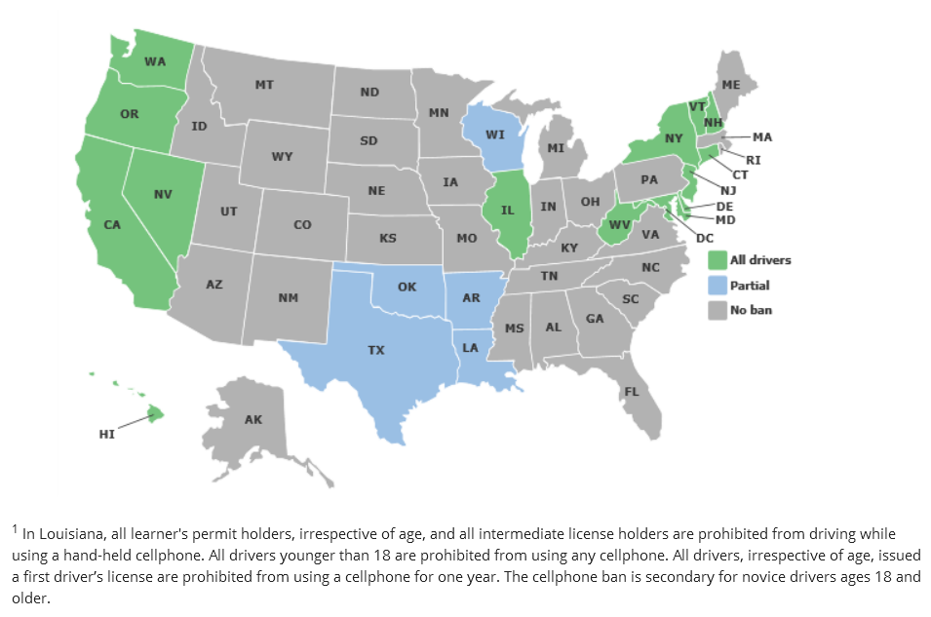
States have attempted to address this issue by banning texting while driving, and placing restrictions on using a hand-held device at all.
States with hand-held bans
Hand-held Cell Phone Use Ban: 14 states, D.C., Puerto Rico, Guam and the U.S. Virgin Islands prohibit all drivers from using hand-held cell phones while driving. All are primary enforcement laws—an officer may cite a driver for using a hand-held cell phone without any other traffic offense taking place.
All Cell Phone Use: No state bans all cell phone use for all drivers, but 38 states and D.C. ban all cell phone use by novice drivers, and 20 states and D.C. prohibit it for school bus drivers.
Source: Insurance Institute for Highway Safety: http://www.iihs.org/iihs/topics/laws/cellphonelaws
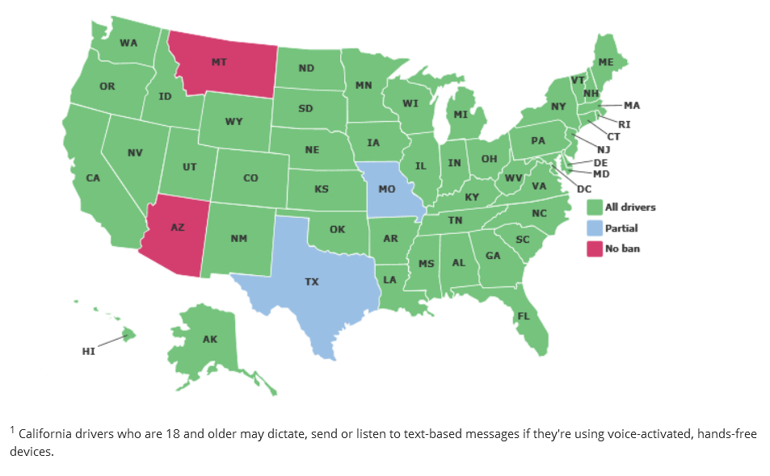
Text Messaging: Washington was the first state to pass a texting ban in 2007. Currently, 46 states, D.C., Puerto Rico, Guam and the U.S. Virgin Islands ban text messaging for all drivers.
State Texting Ban Laws
Crash Data Collection: Nearly all states include at least one category for distraction on police crash report forms, although the specific data collected varies. The Model Minimum Uniform Crash Criteria (MMUCC) guideline provides best practices on distraction data collection.
Source: Insurance Institute for Highway Safety: http://www.iihs.org/iihs/topics/laws/cellphonelaws

Note: Some states have preemption laws that prohibit local jurisdictions from enacting their own distracted driving bans. States with such laws include – but may not be limited to – Florida, Iowa, Kentucky, Louisiana, Mississippi, Nevada, Pennsylvania, Oklahoma, Oregon and South Carolina.

Motor Vehicle Restraints: Seat Belts and Car Seats
Motor vehicle crashes are among the leading cause of death for Americans under 30. According to the National Highway Traffic Safety Administration (NHTSA), in 2009, crashes killed over 33,000 people and injured another 2.2 million. More than half of the people were unrestrained at the time of impact.
In order to encourage vehicle drivers and passengers to wear seatbelts, states have adopted a variety of measures.
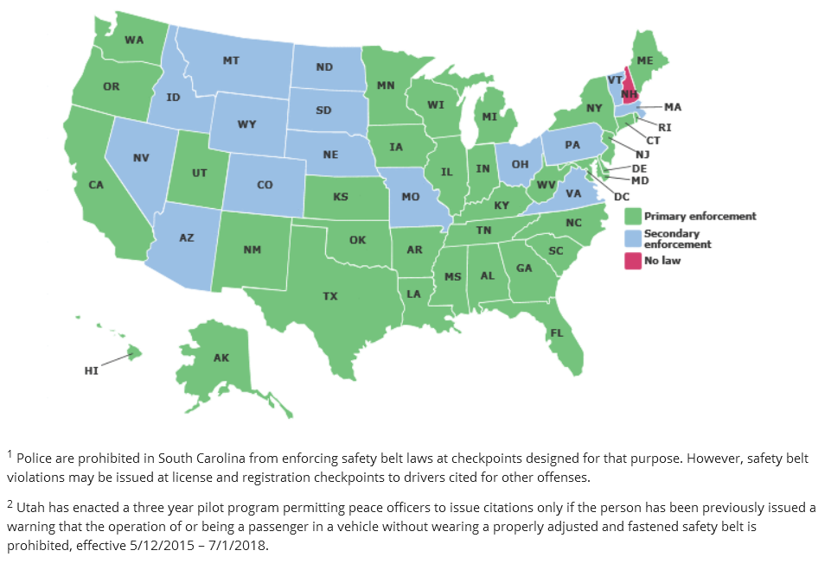
Primary seat belt laws
Primary seat belt laws allow police officers to stop and ticket someone for not wearing a seat belt. In states with secondary seat belt laws, a driver must be pulled over for another violation (speeding or no headlights) before receiving an additional violation for not wearing a seat belt. State laws vary at what age the laws can be enforced. For example, New Mexico has primary enforcement, and it applies to individuals 18 years and older in all seats. Virginia has secondary enforcement, and it applies to those 18 years and older in the front seat. Primary seat belt laws (and proper child restraint laws for children) are much more effective in encouraging vehicle occupants to use seatbelts.
Increased penalties
Increased penalties for violating seat belt laws may include higher fines or points on a driver’s license.
Visibility enforcement campaigns
High-visibility enforcement campaigns involve an increase in police presence at an established checkpoint or intersection. These events are often highly publicized in local media and the results are published to show their effectiveness.
Child restraint laws
Child restraint laws require children of a certain age and weight to be properly restrained in an approved restraint device.
Incentive and education programs
Local police and fire departments can offer car seat safety events and offer to properly install car seats and teach parents the proper installation technique.

Sample ACS Chapter Letter to Legislators on Distracted Driving

DATE
Representative NAME
POSITION
Address
Dear Representative LAST NAME,
The <Name of Chapter> of the American College of Surgeons (ACS) strongly urges you to support legislation that would protect the lives of <state name> road users by ensuring drivers are focused solely on the road, not on their devices.
The ACS is the largest surgical organization in the world with over 80,000 members and approximately XXX in <state name>. The ACS has a strong history of addressing matters related to patient safety and injury prevention and the <Chapter> believes the proposed legislation will save lives. According to the National Highway Traffic Safety Administration (NHTSA), 10 percent of fatal crashes, 18 percent of injury crashes and 16 percent of police-reported motor vehicle crashes were reported as distraction-affected crashes. <DESCRIPTION OF LEGISLATION – Example: This legislation will ban all drivers from using a hand-held device while they are operating their motor vehicles. This bill will allow for primary enforcement of the ban – meaning individuals can be pulled over for using a device.>
According to the NHTSA, the percent of drivers using handheld cell phones has decreased slightly over the past 10 years, but the visible manipulation of handheld devices has more than tripled in the same time frame. Bill XXX will help to ensure law enforcement has the right tools to help reduce distracted driving, and therefore the number of fatal crashes on <state name> roadways moving forward.
In the interest of road safety, the American College of Surgeons urges you to protect all vehicle occupants in <state name> and vote yes on Bill XXX.
Sincerely,

Sample ACS Chapter Letter to Legislators on Seatbelt Legislation

DATE
Representative NAME
POSITION
Address
Dear Representative LAST NAME,
The <Name of Chapter> of the American College of Surgeons (ACS) strongly urges you to support legislation that would protect the lives of <state name> road users by requiring all passengers riding in a motor vehicle to wear proper restraints.
The <ACS Chapter> is the main surgical organization in the state with over XXX members. The <ACS Chapter> has a strong history of addressing matters related to patient safety and injury prevention and the ACS believes the proposed legislation will save lives. According to the National Highway Traffic Safety Administration (NHTSA), XX percent of people used seatbelts in <state name> in 2015. Using a seatbelt is the most effective way to both save lives and reduce the severity of injuries in motor vehicle crashes. Seatbelts reduce serious injuries caused by car crashes by about 50 percent. <DESCRIPTION OF LEGISLATION – Example: This legislation will require all drivers and passengers to wear seatbelts while the vehicle is being operated. It will also allow for primary enforcement of the ban – meaning individuals can be pulled over for not using a seatbelt. Primary enforcement is a more effective mechanism to encourage motor vehicle occupants to wear seatbelts. >
According to the NHTSA, XX number of lives were saved in 2015 by wearing a seatbelt. If 100 percent of individuals had been wearing seatbelts when they crashed, XX more lives would have been saved. Bill XXX will help to ensure law enforcement has the right tools to help ensure motor vehicle occupants are wearing seatbelts, reducing the number fatalities, as well as the severity of injuries, in motor vehicle crashes in <state name> moving forward.
In the interest of passenger safety, the American College of Surgeons urges you to protect all vehicle occupants in <state name> and vote yes on Bill XXX.
Sincerely,

Sample Action Alert to Surgeons – Distracted Driving
Take Action to Stop Distracted Driving in STATE
On DATE, the STATE House Committee on <NAME> will hear Bill #, a bill to institute a ban using a handheld device while driving. This bill would ban all drivers (with exception for emergency personnel) from using a handheld device while driving. It includes a primary enforcement mechanism – which means a driver can be pulled over directly for using a device while driving.
The National Highway Transportation Administration estimates that 10 percent of fatal crashes, 18 percent of injury crashes and 16 percent of police-reported motor vehicle crashes were reported as distraction-affected crashes. Of these distracted driving related crashes, at least 13 percent were directly linked to hand held device usage. These numbers are even higher for individuals under the age of 29, who are much more likely to be distracted by a hand-held device.
Please send a message to your Representative today and urge them to support Bill #. Tell them that distracted driving kills. Please feel free to edit the draft letter text to share your own perspective on this important issue. Take action today!
Message to Legislators
I am writing you today to ask you to support efforts to institute a ban on using handheld devices while driving. Representative NAME has introduced BILL #, which would ban all drivers (with exception for emergency personnel) from using a handheld device while driving. It includes a primary enforcement mechanism – which means a driver can be pulled over directly for using a device while driving.
This bill would be extremely beneficial for the residents in our state. The National Highway Transportation Administration estimates that 10 percent of fatal crashes, 18 percent of injury crashes and 16 percent of police-reported motor vehicle crashes were reported as distraction-affected crashes. Of these distracted driving related crashes, at least 13 percent were directly linked to hand held device usage. These numbers are even higher for individuals under the age of 29, who are much more likely to be distracted by a hand-held device.
Please support this bill if it comes up to a vote in the Committee XXX.
Phone Talking Points
- My name is <name>, I am a surgeon practicing in <location> and I’m calling today to ask Representative/Senator <NAME> to support Bill #, which would ban all drivers (with exception for emergency personnel) from using a handheld device while driving.
- Distracted driving is a dangerous practice which can cause fatal crashes. We need to provide the right tools to law enforcement to ensure this practice stops.
- Please tell Representative/Senator <NAME> to support Bill # if it comes up to a vote in the COMMITTEE
Sample Action Alert – Seatbelts
Take Action to Save Lives in STATE
On DATE, the STATE House Committee on <NAME> will hear Bill #, a bill to require all passengers riding in a motor vehicle to wear proper restraints. It will also allow for primary enforcement of the ban – meaning individuals can be pulled over for not using a seatbelt. Primary enforcement is a more effective mechanism to encourage motor vehicle occupants to wear seatbelts.
According to the National Highway Traffic Safety Administration (NHTSA), X percent of people used seatbelts in STATE in 2015. Using a seatbelt is the most effective way to both save lives and reduce the severity of injuries in motor vehicle crashes. Seatbelts reduce serious injuries caused by car crashes by about 50 percent. Please send a message to your legislator today and urge them to support Bill #.
Tell them that wearing seatbelts saves lives and reduces injuries. Please feel free to edit the draft letter text to share your own perspective on this important issue. Take action today!
Message to Legislators
I am writing you today to ask you to support legislation that will require all passengers riding in a motor vehicle to wear proper restraints. In addition, <Bill #> will allow for primary enforcement of the ban – meaning individuals can be pulled over for not using a seatbelt. Primary enforcement is a more effective mechanism to encourage motor vehicle occupants to wear seatbelts.
This bill would be extremely beneficial for our state. Seatbelts save lives. According to the National Highway Traffic Safety Administration (NHTSA), X percent of people used seatbelts in STATE in 2015. Using a seatbelt is the most effective way to both save lives and reduce the severity of injuries in motor vehicle crashes. Seatbelts reduce serious injuries caused by car crashes by about 50 percent. XX number of lives were saved in 2015 by wearing a seatbelt in STATE. If 100 percent of individuals had been wearing seatbelts when they crashed, XX more lives would have been saved.
Please support this bill if it comes up to a vote in the Committee XXX.
Phone Talking Points
- My name is <name>, I am a surgeon practicing in <location> and I’m calling today to ask Representative/Senator <NAME> to support legislation to require all motor vehicle occupants to wear a seatbelt when the vehicle is in motion.
- LEGISLATOR has introduced this legislation, Bill #, which would also create a primary enforcement mechanism, which is a better tool to encourage occupants to wear a seatbelt.
- Seatbelts save lives. Bill # will ensure more people in STATE wear seatbelts.
- Please tell Representative/Senator <NAME> to support Bill # if it comes up to a vote in the COMMITTEE

Sample Bill: Connecticut Distracted Driving Statute
a) For purposes of this section, the following terms have the following meanings:
(1) "Mobile telephone" means a cellular, analog, wireless or digital telephone capable of sending or receiving telephone communications without an access line for service.
(2) "Using" or "use" means holding a hand-held mobile telephone to, or in the immediate proximity of, the user's ear.
(3) "Hand-held mobile telephone" means a mobile telephone with which a user engages in a call using at least one hand.
(4) "Hands-free accessory" means an attachment, add-on, built-in feature, or addition to a mobile telephone, whether or not permanently installed in a motor vehicle, that, when used, allows the vehicle operator to maintain both hands on the steering wheel.
(5) "Hands-free mobile telephone" means a hand-held mobile telephone that has an internal feature or function, or that is equipped with an attachment or addition, whether or not permanently part of such hand-held mobile telephone, by which a user engages in a call without the use of either hand, whether or not the use of either hand is necessary to activate, deactivate or initiate a function of such telephone.
(6) "Engage in a call" means talking into or listening on a hand-held mobile telephone, but does not include holding a hand-held mobile telephone to activate, deactivate or initiate a function of such telephone.
(7) "Immediate proximity" means the distance that permits the operator of a hand-held mobile telephone to hear telecommunications transmitted over such hand-held mobile telephone, but does not require physical contact with such operator's ear.
(8) "Mobile electronic device" means any hand-held or other portable electronic equipment capable of providing data communication between two or more persons, including a text messaging device, a paging device, a personal digital assistant, a laptop computer, equipment that is capable of playing a video game or a digital video disk, or equipment on which digital photographs are taken or transmitted, or any combination thereof, but does not include any audio equipment or any equipment installed in a motor vehicle for the purpose of providing navigation, emergency assistance to the operator of such motor vehicle or video entertainment to the passengers in the rear seats of such motor vehicle.
(b) (1) Except as otherwise provided in this subsection and subsections (c) and (d) of this section, no person shall operate a motor vehicle upon a highway, as defined in section 14-1, while using a hand-held mobile telephone to engage in a call or while using a mobile electronic device while such vehicle is in motion. An operator of a motor vehicle who types, sends or reads a text message with a hand-held mobile telephone or mobile electronic device while such vehicle is in motion shall be in violation of this section, except that if such operator is driving a commercial motor vehicle, as defined in section 14-1, such operator shall be charged with a violation of subsection (e) of this section.
(2) An operator of a motor vehicle who holds a hand-held mobile telephone to, or in the immediate proximity of, his or her ear while such vehicle is in motion is presumed to be engaging in a call within the meaning of this section. The presumption established by this subdivision is rebuttable by evidence tending to show that the operator was not engaged in a call.
(3) The provisions of this subsection shall not be construed as authorizing the seizure or forfeiture of a hand-held mobile telephone or a mobile electronic device, unless otherwise provided by law.
(4) Subdivision (1) of this subsection shall not apply to: (A) The use of a hand-held mobile telephone for the sole purpose of communicating with any of the following regarding an emergency situation: An emergency response operator; a hospital, physician's office or health clinic; an ambulance company; a fire department; or a police department, or (B) any of the following persons while in the performance of their official duties and within the scope of their employment: A peace officer, as defined in subdivision (9) of section 53a-3, a firefighter or an operator of an ambulance or authorized emergency vehicle, as defined in section 14-1, or a member of the armed forces of the United States, as defined in section 27-103, while operating a military vehicle, or (C) the use of a hand-held radio by a person with an amateur radio station license issued by the Federal Communications Commission, or (D) the use of a hands-free mobile telephone.
(c) No person shall use a hand-held mobile telephone or other electronic device, including those with hands-free accessories, or a mobile electronic device while operating a moving school bus that is carrying passengers, except that this subsection shall not apply to (1) a school bus driver who places an emergency call to school officials, or (2) the use of a hand-held mobile telephone as provided in subparagraph (A) of subdivision (4) of subsection (b) of this section.
(d) No person under eighteen years of age shall use any hand-held mobile telephone, including one with a hands-free accessory, or a mobile electronic device while operating a moving motor vehicle on a public highway, except as provided in subparagraph (A) of subdivision (4) of subsection (b) of this section.
(e) No person shall use a hand-held mobile telephone or other electronic device or type, read or send text or a text message with or from a mobile telephone or mobile electronic device while operating a commercial motor vehicle, as defined in section 14-1, except for the purpose of communicating with any of the following regarding an emergency situation: An emergency response operator; a hospital; physician's office or health clinic; an ambulance company; a fire department or a police department.
(f) Except as provided in subsections (b) to (e), inclusive, of this section, no person shall engage in any activity not related to the actual operation of a motor vehicle in a manner that interferes with the safe operation of such vehicle on any highway, as defined in section 14-1.
(g) Any law enforcement officer who issues a summons for a violation of this section shall record on such summons the specific nature of any distracted driving behavior observed by such officer.
(h) Any person who violates this section shall be fined one hundred fifty dollars for a first violation, three hundred dollars for a second violation and five hundred dollars for a third or subsequent violation.
(i) An operator of a motor vehicle who commits a moving violation, as defined in subsection (a) of section 14-111g, while engaged in any activity prohibited by this section shall be fined in accordance with subsection (h) of this section, in addition to any penalty or fine imposed for the moving violation.
(j) The state shall remit to a municipality twenty-five per cent of the fine amount received for a violation of this section with respect to each summons issued by such municipality. Each clerk of the Superior Court or the Chief Court Administrator, or any other official of the Superior Court designated by the Chief Court Administrator, shall, on or before the thirtieth day of January, April, July and October in each year, certify to the Comptroller the amount due for the previous quarter under this subsection to each municipality served by the office of the clerk or official.
(k) A record of any violation of this section shall appear on the driving history record or motor vehicle record, as defined in section 14-10, of any person who commits such violation, and the record of such violation shall be available to any motor vehicle insurer in accordance with the provisions of section 14-10.

Model Seatbelt Bill (based on California’s Motor Vehicle Safety Act)

(a) The Legislature finds that a mandatory seatbelt law will contribute to reducing highway deaths and injuries by encouraging greater usage of existing manual seatbelts, that automatic crash protection systems that require no action by vehicle occupants offer the best hope of reducing deaths and injuries, and that encouraging the use of manual safety belts is only a partial remedy for addressing this major cause of death and injury. The Legislature declares that the enactment of this section is intended to be compatible with support for federal motor vehicle safety standards requiring automatic crash protection systems and should not be used in any manner to rescind federal requirements for installation of automatic restraints in new cars.

(b) This section shall be known and may be cited as the Motor Vehicle Safety Act.
(c) (1) As used in this section, "motor vehicle" means a passenger vehicle, a motor truck, or a truck tractor, but does not include a motorcycle.
(2) For purposes of this section, a "motor vehicle" also means a farm labor vehicle.
(d) (1) A person shall not operate a motor vehicle on a highway unless that person and all passengers 8 years of age or over are properly restrained by a safety belt. The safety belt requirement established by this paragraph is the minimum safety standard applicable to employees being transported in a motor vehicle. This paragraph does not preempt more stringent or restrictive standards imposed by the Labor Code or another state or federal regulation regarding the transportation of employees in a motor vehicle.
(2) For purposes of this section the phrase, "properly restrained by a safety belt" means that the lower (lap) portion of the belt crosses the hips or upper thighs of the occupant and the upper (shoulder) portion of the belt, if present, crosses the chest in front of the occupant.
(3) The operator of a limousine for hire or the operator of an authorized emergency vehicle, as defined in subdivision (a) of Section 165, shall not operate the limousine for hire or authorized emergency vehicle unless the operator and any passengers eight years of age or over in the front seat, are properly restrained by a safety belt.
(4) The operator of a taxicab shall not operate the taxicab unless all passengers are properly restrained by a safety belt.
(e) A person 16 years of age or over shall not be a passenger in a motor vehicle on a highway unless that person is properly restrained by a safety belt.
(f) An owner of a motor vehicle, including an owner or operator of a taxicab, as defined in Section XXXXX, or a limousine for hire, operated on a highway shall maintain safety belts in good working order for the use of the occupants of the vehicle. The safety belts shall conform to motor vehicle safety standards established by the United States Department of Transportation. This subdivision, however, does not require installation or maintenance of safety belts if it is not required by the laws of the United States applicable to the vehicle at the time of its initial sale.
(g) This section does not apply to a passenger or operator with a physically disabling condition or medical condition that would prevent appropriate restraint in a safety belt, if the condition is duly certified by a licensed physician and surgeon or by a licensed chiropractor who shall state the nature of the condition, as well as the reason the restraint is inappropriate. This section also does not apply to a public employee, if the public employee is in an authorized emergency vehicle as defined in paragraph (1) of subdivision (b) of Section 165, or to a passenger in a seat behind the front seat of an authorized emergency vehicle as defined in paragraph (1) of subdivision (b) of Section 165 operated by the public employee, unless required by the agency employing the public employee.
(h) Notwithstanding subdivision (a) of Section XXXX, a violation of subdivision (d), (e), or (f) is an infraction punishable by a fine of not more than twenty dollars ($20) for a first offense, and a fine of not more than fifty dollars ($50) for each subsequent offense. In lieu of the fine and any penalty assessment or court costs, the court, pursuant to Section XXXX, may order that a person convicted of a first offense attend a school for traffic violators or another court-approved program in which the proper use of safety belts is demonstrated.

(i) This section does not apply to a person actually engaged in delivery of newspapers to customers along the person's route if the person is properly restrained by a safety belt prior to commencing and subsequent to completing delivery on the route.
(j) This section does not apply to a person actually engaged in collection and delivery activities as a rural delivery carrier for the United States Postal Service if the person is properly restrained by a safety belt prior to stopping at the first box and subsequent to stopping at the last box on the route.
(k) This section does not apply to a driver actually engaged in the collection of solid waste or recyclable materials along that driver's collection route if the driver is properly restrained by a safety belt prior to commencing and subsequent to completing the collection route.
(l) Subdivisions (d), (e), (f), (g), and (h) shall become inoperative immediately upon the date that the United States Secretary of Transportation, or his or her delegate, determines to rescind the portion of the Federal Motor Vehicle Safety Standard No. 208 (49 C.F.R. 571.208) that requires the installation of automatic restraints in new motor vehicles, except that those subdivisions shall not become inoperative if the secretary's decision to rescind that Standard No. 208 is not based, in any respect, on the enactment or continued operation of those subdivisions.

27315.1. Section 27315 applies to any person in a fully enclosed three-wheeled motor vehicle that is not less than seven feet in length and not less than four feet in width, and has an unladen weight of 900 pounds or more.

Resources
National Highway Traffic Safety Administration National Center for Statistical Analysis Reports
- Traffic Safety Facts: 2014 Data – Occupant Protection: https://crashstats.nhtsa.dot.gov/Api/Public/ViewPublication/812262.
- Early estimate of motor vehicle traffic fatalities for the first half (Jan–Jun) of 2016: https://crashstats.nhtsa.dot.gov/Api/Public/ViewPublication/812332.
- Distracted driving 2014: https://crashstats.nhtsa.dot.gov/Api/Public/ViewPublication/812260.
- Seat belt use in 2015—Use rates in the States and Territories: https://crashstats.nhtsa.dot.gov/Api/Public/ViewPublication/812274.
- Traffic Safety Facts: Seat Belt Use in 2015 – Overall Results: http://www-nrd.nhtsa.dot.gov/Pubs/812243.pdf.
- Lives Saved in 2015 by Restraint Use and Minimum-Drinking-Age Laws: https://crashstats.nhtsa.dot.gov/Api/Public/ViewPublication/812319
- Driver Electronic Device Use in 2015: https://crashstats.nhtsa.dot.gov/Api/Public/ViewPublication/812326
- 2015 Motor Vehicle Crashes: Overview: https://crashstats.nhtsa.dot.gov/Api/Public/ViewPublication/812318
- All NHTSA Crashstats Reports available here: https://crashstats.nhtsa.dot.gov/#/
Other Studies and Resources
- Kahane CJ. Fatality reduction by safety belts for front-seat occupants of cars and light trucks: updated and expanded estimates based on 1986-99 FARS data. Washington, DC: US Department of Transportation, National Highway Traffic Safety Administration; 2000. Publication no. DOT-HS-809-199. Available at http://www-nrd.nhtsa.dot.gov/Pubs/809199.PDF.
- Centers for Disease Control and Prevention – Seat Belts: Get the Facts. Available at: http://www.cdc.gov/motorvehiclesafety/seatbelts/facts.html.
- Centers for Disease Control and Prevention – Distracted Driving. Available at: http://www.cdc.gov/motorvehiclesafety/Distracted_Driving/index.html.
- Distraction.Gov – U.S. Government Website for Distracted Driving. Available at: http://www.distraction.gov/index.html
- Governors Highway Safety Association Report on Curbing Distracted Driving 2010 - Survey of State Safety Programs: Available at: http://www.ghsa.org/html/files/pubs/survey/2010_distraction.pdf.
- Governors Highway Safety Association 2011 Report: Distracted Driving: What Research Shows and What States Can Do. Available at: http://www.ghsa.org/html/publications/sfdist.html.
- Governors Highway Safety Association Report – 2013 Distracted Driving: Survey of the States: Available at: http://www.ghsa.org/html/publications/survey/distraction2013.html
- Governors Highway Safety Association - Occupant Protection: http://www.ghsa.org/html/issues/occprotection/index.html
- Insurance Institute for Highway Safety/Highway Loss Data Institute – General Statistics State by State 2014: http://www.iihs.org/iihs/topics/t/general-statistics/fatalityfacts/overview-of-fatality-facts/2014
- Insurance Institute for Highway Safety/Highway Loss Data Institute – Safety belts: http://www.iihs.org/iihs/topics/t/safety-belts/topicoverview
- Insurance Institute for Highway Safety/Highway Loss Data Institute – Distracted Driving: http://www.iihs.org/iihs/topics/t/distracted-driving/topicoverview
- Insurance Institute for Highway Safety/Highway Loss Data Institute – Cell Phone Laws: http://www.iihs.org/iihs/topics/laws/cellphonelaws.
- National Conference of State Legislatures Spotlight on Distracted Driving, available at: http://www.ncsl.org/research/transportation/spotlight-distracted-driving.aspx.
- National Highway Traffic Safety Administration Policy Statement and FAQs: http://www.nhtsa.gov/Driving+Safety/Distracted+Driving+at+Distraction.gov/Policy+Statement+and+Compiled+FAQs+on+Distracted+Driving

